COMHAIRLE CONTAE AN LONGFOIRT

LONGFORD COUNTY COUNCIL

Corporate Affairs,
Aras an Chontae,
LONGFOIRT.

15th October 2014.

To: The Cathaoirleach and Members of Longford County Council

A Chomhairleoir,

You are requested to attend a Special Meeting of Longford County Council to be held in the Council Chamber, Aras an Chontae, Great Water Street, Longford on Wednesday, 22nd October 2014 at 6.00 p.m. to consider the ongoing financial crisis at St. Christopher’s Services, Longford.

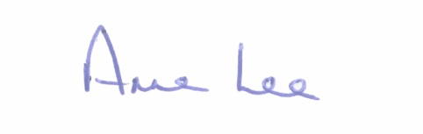
Mise le meas,

Anne Lee
Meetings Administrator.

